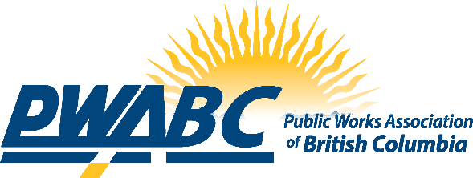

Annual Awards Application

Please indicate award:

󠄀 Dedicated Service
󠄀 Manager of the Year
󠄀 Professional Dedicated Service
󠄀 Emerging Leader of the Year
󠄀 Women's Public Works Ambassador
󠄀 Outstanding Public Works Employee
󠄀 Project of the Year
󠄀 Public Works Week Celebration

Candidate’s Name:
Title:
Agency/Organization:
Mailing Address (If post office box, include street address):
City:
Province: Postal Code
Phone:
Email:

Nominating Organization/Individual:
Title:
Agency/Organization:
Mailing Address (If post office box, include street address)
City
Province: Postal Code
Email:

Deadline: October 15th

Forward this form along with documentation supporting the award nomination and the award’s eligibility requirements to:

Via Email: membership@pwabc.ca

